
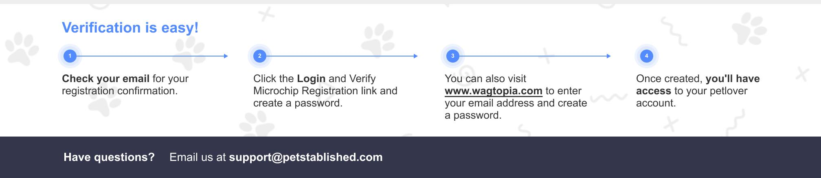
What do I do if my pet gets lost?
First, log in to your Petlover account. Under the Microchip column, click ‘Report Lost Pet.’ Confirm your pet’s microchip number and enter as many details as possible (i.e. age, breed, color, weight, distinguishing marks/features, place last seen). We will post a lost pet alert, and we will notify you if someone finds your pet.

My pet has a smart tag. How does it work?
If a pet is lost, when their tag is scanned, the finder is immediately brought to your pet’s page in our microchip registry. You receive an email alert with the location of where your pet’s tag was scanned. You and the finder can then make arrangements for you to pick up your pet!

How can I change my information?
Visit www.petstablished.com, log in to your Petlover account, and click on Edit Pet/Update Microchip Information or Edit Registration. There is no cost.

Can anyone use the microchip to track my pet and see their location?
No, microchips cannot show the location of your pet or track your pet in any way.

Clinic Custom Question/Remark
LIMIT 2 LINES ARIAL 8 FONT**
What is a microchip?
A microchip is a small, electronic chip or transponder that is about the same size as a grain of rice that is set to a certain radio frequency. It is not battery operated—it is activated by a scanner that is passed over the area. Radio waves from the scanner activate the chip, the chip transmits the identification number to the scanner, and the microchip number is displayed on the scanner’s screen. Your pet is fitted with a registered microchip, which is a lifetime registration.

How and where are microchips placed?
Microchips are placed using a small needle in between your pet’s shoulder blades, just underneath the skin. The site may be a little tender for a day or two but after that should not bother them at all.

Since my pet has a microchip, does this mean they do not need to wear an ID tag?
There is no safer option for a lost pet than an ID tag, and they should wear one at all times. Although it’s rare, microchips can fail or move around so the vet can no longer locate them. An ID tag is a 100% guarantee your information is available to the finder of your lost pet.

Is my pet still registered if I do not set up a Petlover account?
Your pet’s microchip is registered with Petstablished and the American Animals Hospital Association (AAHA), the largest centralized database for pet microchip lookup in the country.
FREQUENTLY ASKED QUESTIONS ABOUT MICROCHIPS
Pet Description: «AnimalPrimaryColor»
«AnimalSpecies» «AnimalSex» «AnimalBreed»«AnimalAgeYear» yr. «AnimalAgeMonths» mo.

Owner Info: «Ownername»
«ClientPhoneCell»

«ClientName»«ClientAddressLine1» «ClientAddressLine2»
«ClientAddressCity», «ClientAddressState» «ClientAddressZip»

Note: It takes 24 hours for our system to update.
You should get an email tomorrow with confirmation of your pet’s registration. If you do not, please email support@petstablished.com.
PET / OWNER INFORMATION
Great news! Your pet has been registered with Petstablished!
There’s one more important thing to do – log in to your Petlover Account (Petstablished has created one for you) so you can update information later on. It’s free of charge and it’s easy to do. If you need help, email support@petstablished.com.
Pet Name: «AnimalName»
Pet Microchip Number: «AnimalMicrochip»

