
SUPER AWESOME SPAY & NEUTER CLINIC
123 N. Main Street, Portland, Oregon 55555 | 303.868.2247
HIGH RISK WAIVER

OWNER | Owner  «Ownername» «VolumeClientName»  «OwnerAddressLine1» «OwnerAddressLine2» «OwnerAddressCity», «OwnerAddressState» «OwnerAddressZip»  Cell: «OwnerPhoneCell» Home: «OwnerPhoneHome» «OwnerEmail» | Appointment Date  «AppointmentDate»

ANIMAL | Name  «AnimalName» | Description  «AnimalSpecies» / «AnimalSex» /«AnimalBreed» /«AnimalAgeYear» yr, «AnimalAgeMonths» mo/ «AnimalPrimaryColor»/«AnimalSecondaryColor»  Notes: «AnimalNotes» «AnimalShortNotes»  DRAFT | Services Requested:  «TableStart:Services» «ItemName» «TableEnd:Services»

INSTRUCTIONS:
TO ACCEPT THIS WAIVER: BY SIGNING THIS WAIVER, YOU AGREE TO ACCEPT THE SURGICAL RISKS OUTLINED BELOW. WE WILL PERFORM SURGERY ON YOUR PET AFTER SIGNING.
TO DECLINE THIS WAIVER: CLICK “OPTIONS” IN THE UPPER RIGHT CORNER AND SELECT “DECLINE TO SIGN.”
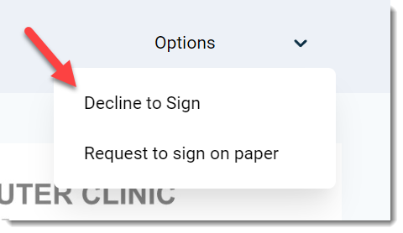

HIGH RISK WAIVER
Upon examination by one of our veterinarians and/or based on medical records submitted, your pet was discovered to have the following:
«HrwReasons»
Appointment Vet: «AppointmentVet»

The condition(s) noted above may represent an increased surgical or anesthetic risk. By performing surgery your pet may experience complications and even death. However, the doctor is willing to proceed with surgery, if you so choose. By signing below, you as the owner, acknowledge that “CLINIC NAME” staff has informed me of the increased risk to my animal as the result of the conditions identified above, and I understand and agree to accept these risks and/or forgo recommendations for pre-surgical testing; I elect to proceed with spay/neuter surgery.
I acknowledge that any additional issues, complications, or costs associated with proceeding with this anesthesia/surgery are my responsibility.
DRAFT
I accept that no guarantee of successful treatment has been made.
I agree that all questions and concerns about the risk posed to my animal have been answered to my satisfaction.

BY SIGNING BELOW, I ACKNOWLEDGE I READ, UNDERSTOOD, & AGREE TO THE TERMS IN THIS AGREEMENT.

SIGNATURE OF OWNER OR AUTHORIZED AGENT:

DATE:

